Configuring Jenkins server for CI pipeline

1. We use Jenkins to build the application and produce some artifacts the artifacts eventually go to the VM, storage, container, container instance any where it can be stored.
2. Azure pipeline we can use ONLY for CD – Continuous Delivery but the build will continue with Jenkins-Run the CI Jobs in Jenkins separately

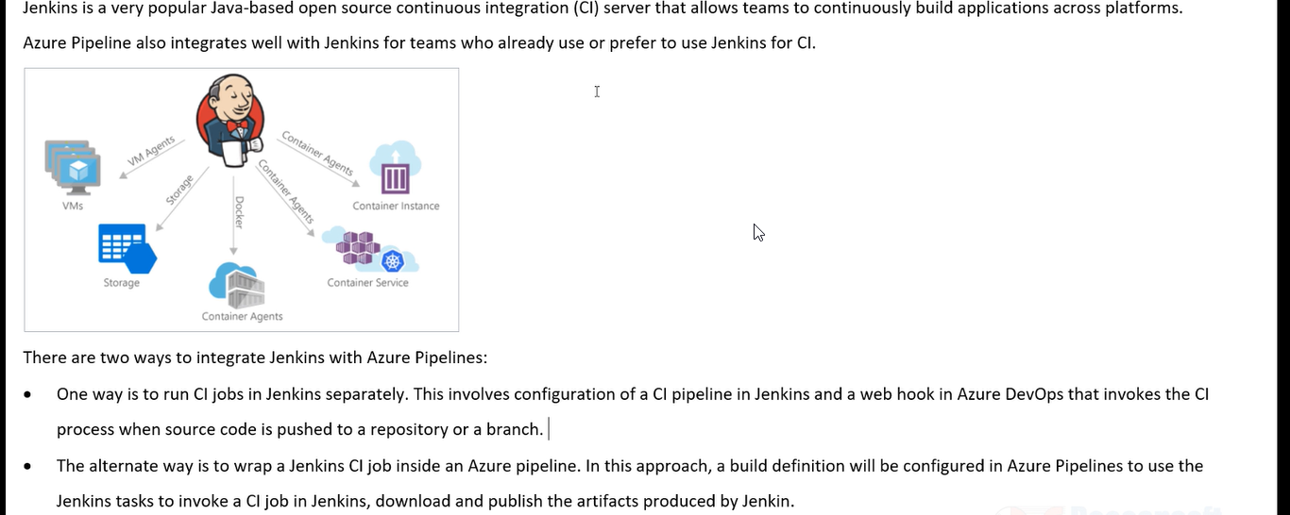

As soon as I push my source code into repository immediately in background it is going to use the webhook and using the webhook Jenkins will know that latest code has come, Jenkins then would pull the latest code from Azure repo and then compile the code

Or we can build the Jenkins pipeline and from your pipeline you create a Jenkins job. From my pipeline we can invoke jenkins pipeline

Setting up the Jenkins VM

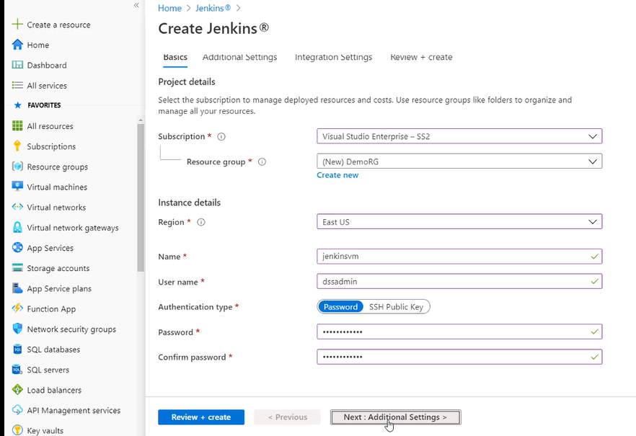

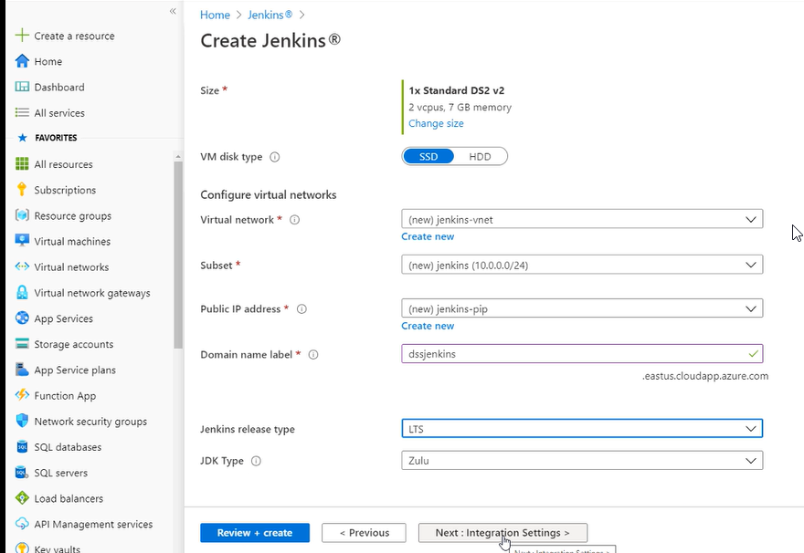

Jenkins is based on java-based project and select all default values and click on create

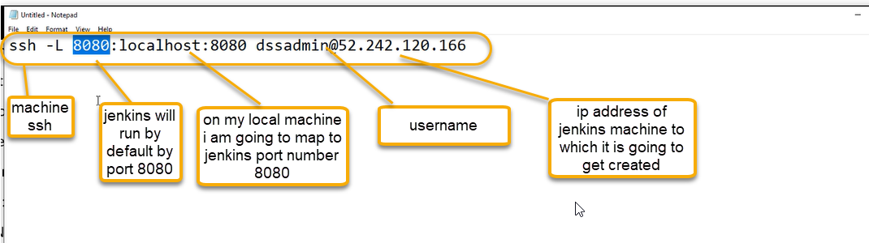

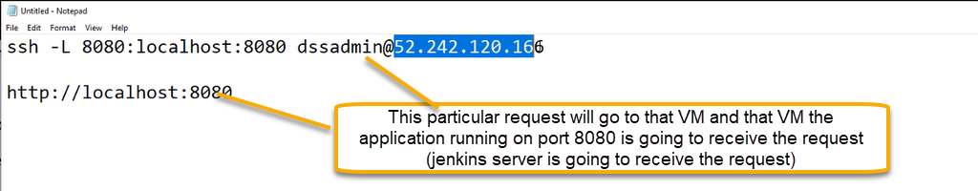

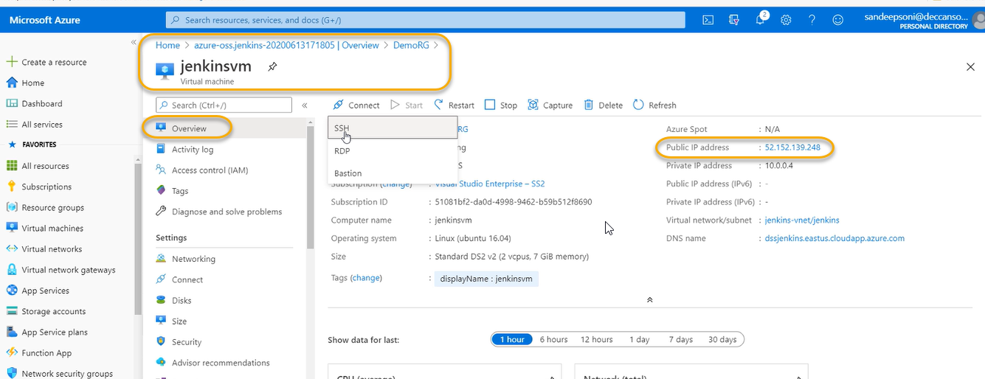

Connecting to Jenkins from Browser

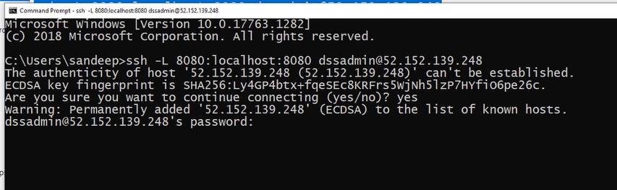

At the time of creation what you gave the password use that

For security reasons, Jenkins generates an initial password and save it in a file on the server. This password

will need to be retrieved and provided to unlock Jenkins

$ sudo cat /var/lib/jenkins/secrets/initialAdminPassword

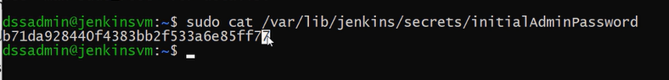

Note the password

And Now browse localhost:8080

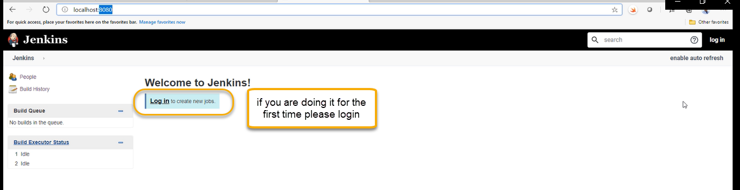

Click on Log In as highlighted above

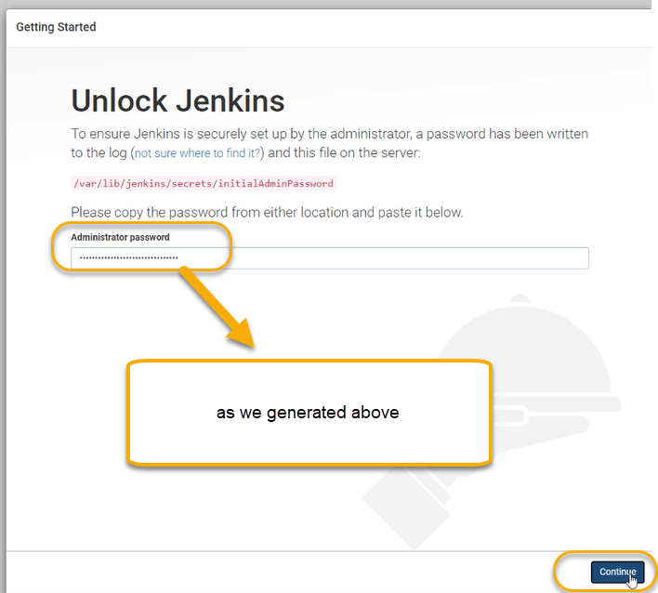

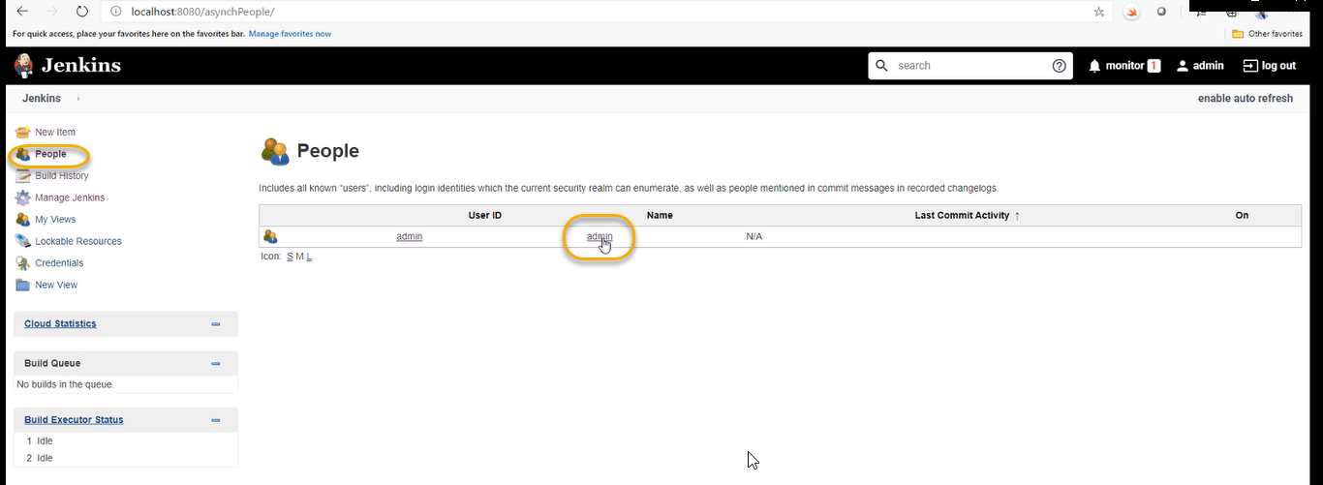

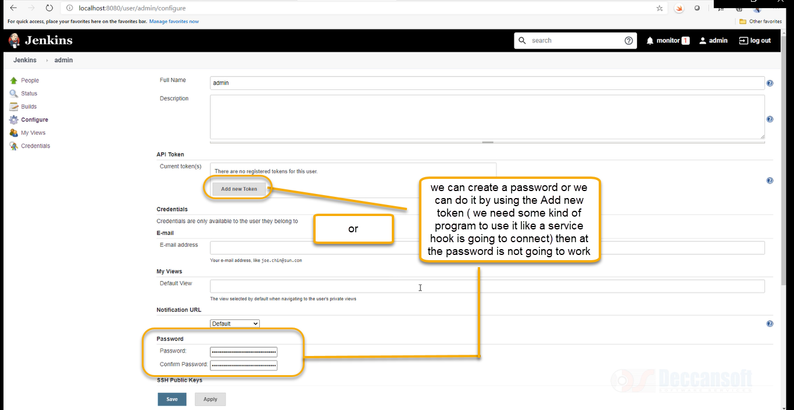

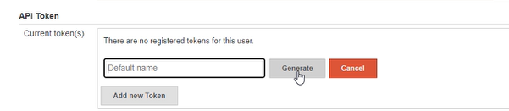

We can give some name for API token, or we can generate it

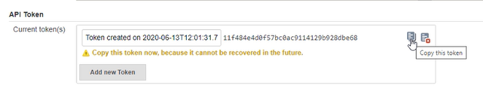

Wherever we need to connect to automation tools to Jenkins we need use this api token

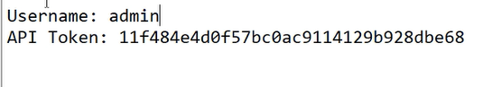

When ever we need to login to Jenkins we will use the user name as admin and password as API token the first you login is generated as a sudo command as we see above

Installing and Configuring Plugins

Manage Jenkins > Manage Plugins > Available tab > search for Team Services > Select VS Team

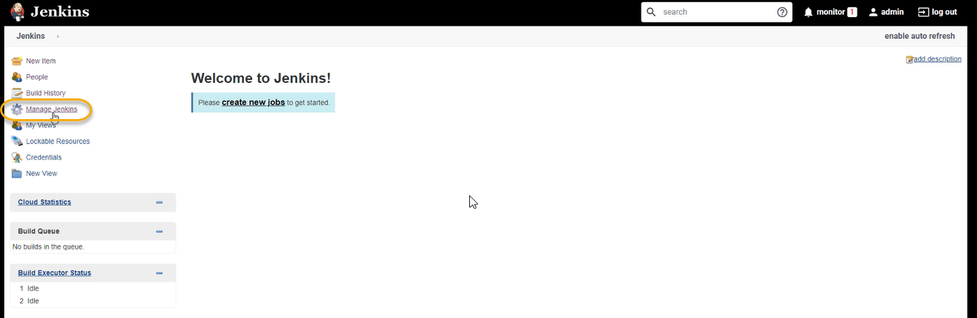

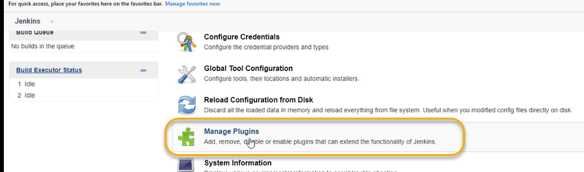

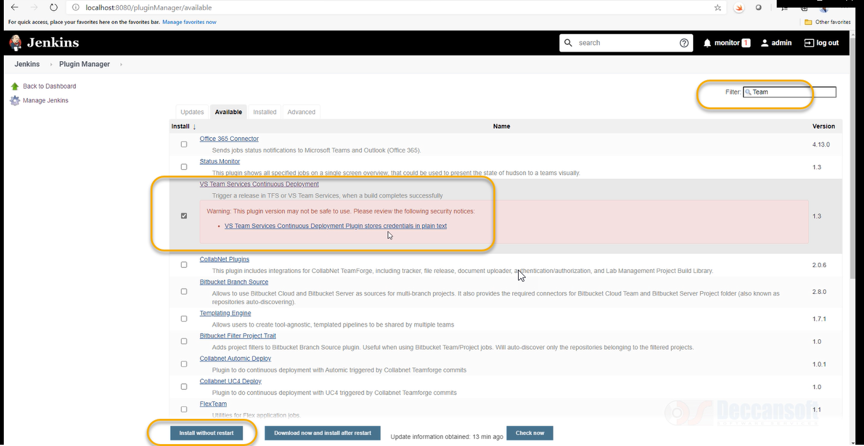

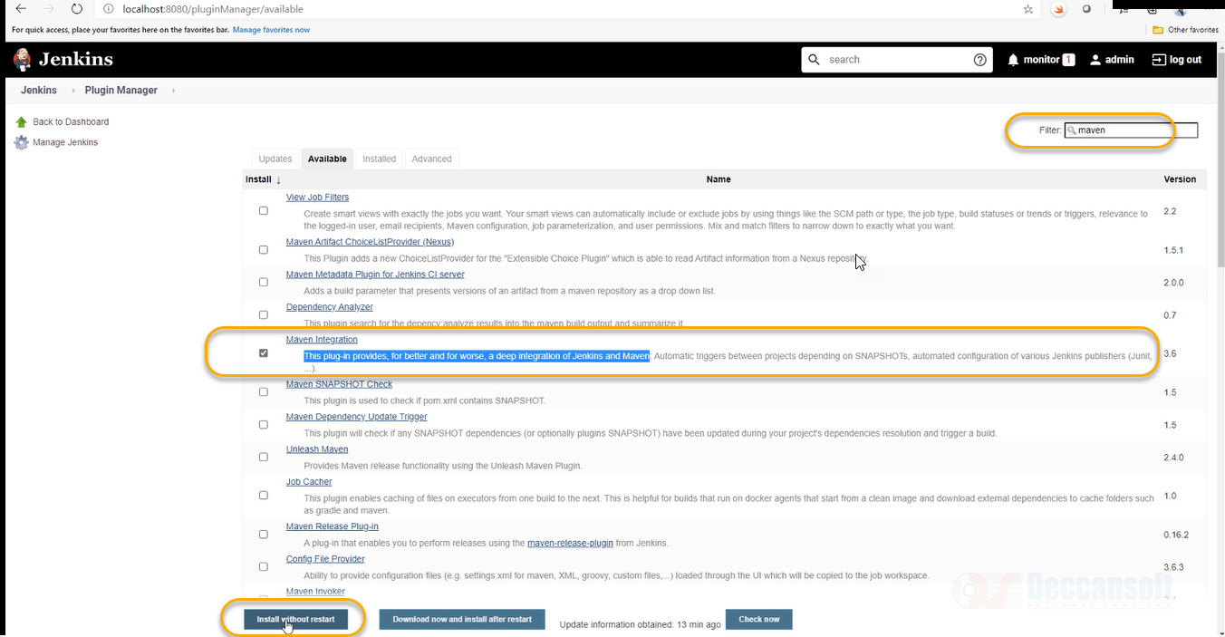

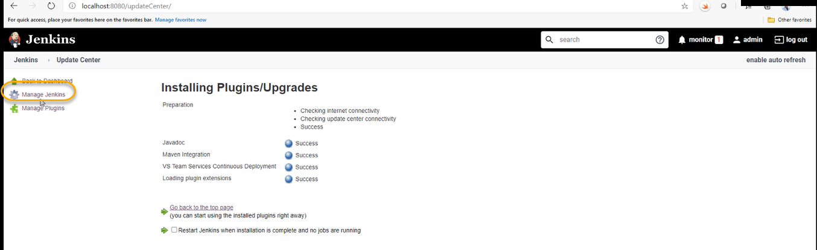

Click on the Manage Jenkins as highlighted above and select the Global Tool Configuration

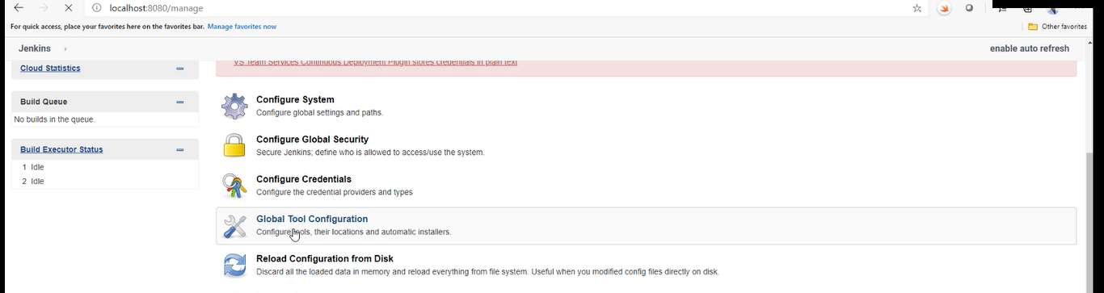

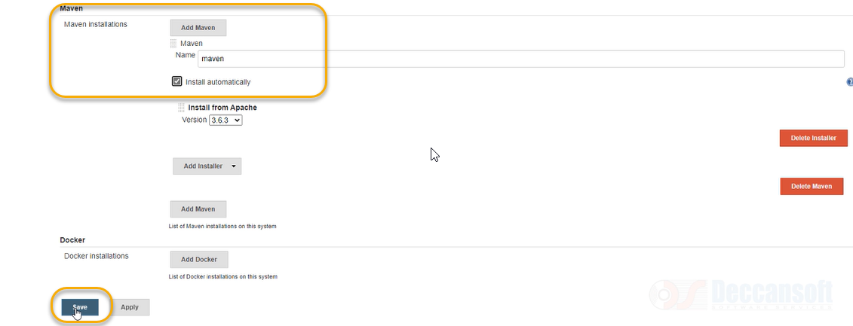

Services Continuous Deployment plugin and select Install without restart

Preparing Jenkins machine to use service hook in Azure DevOps

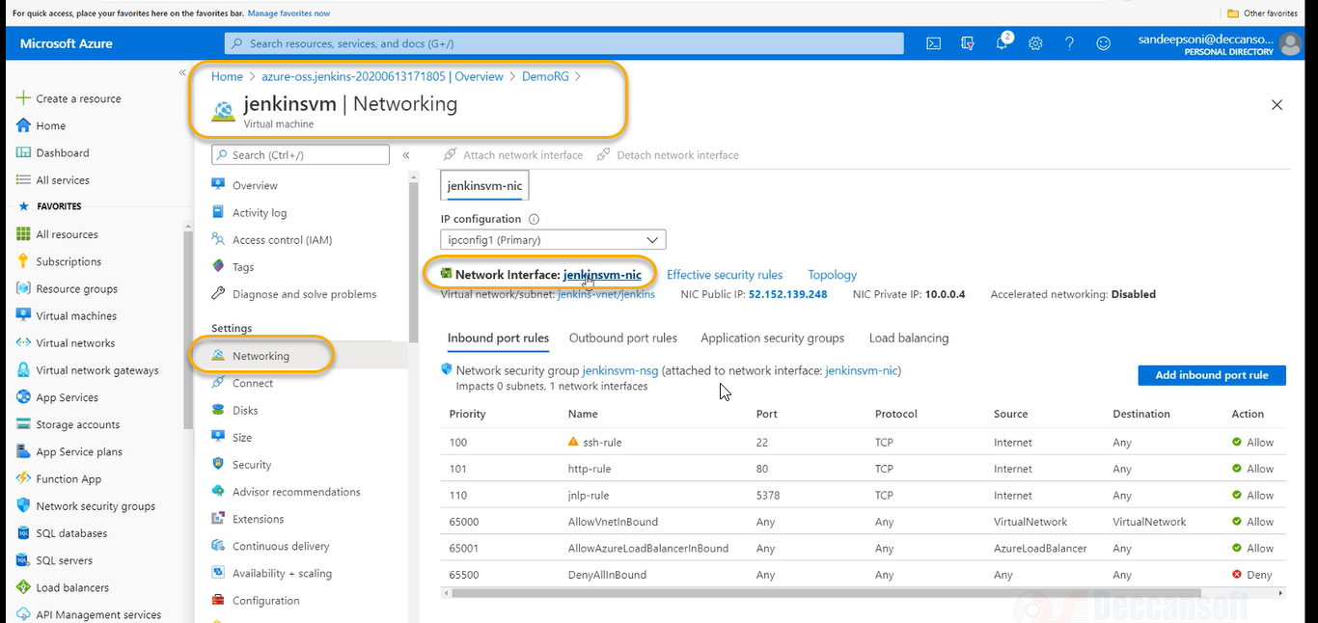

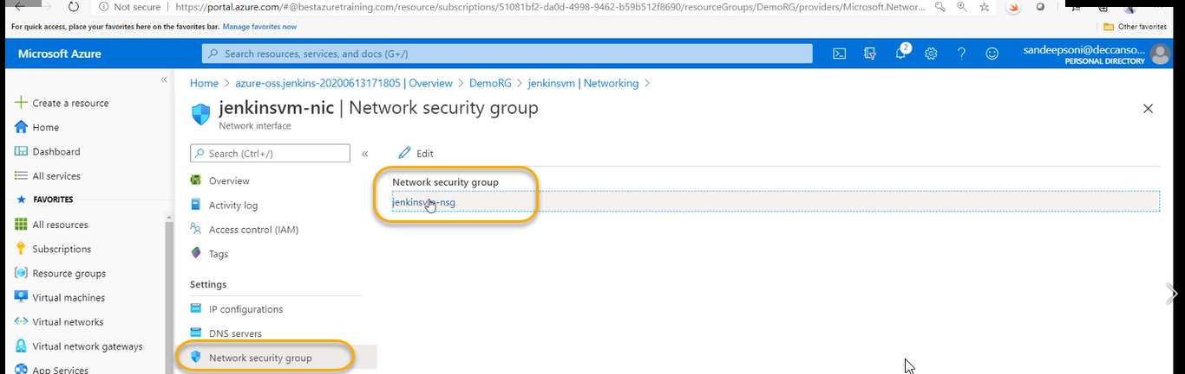

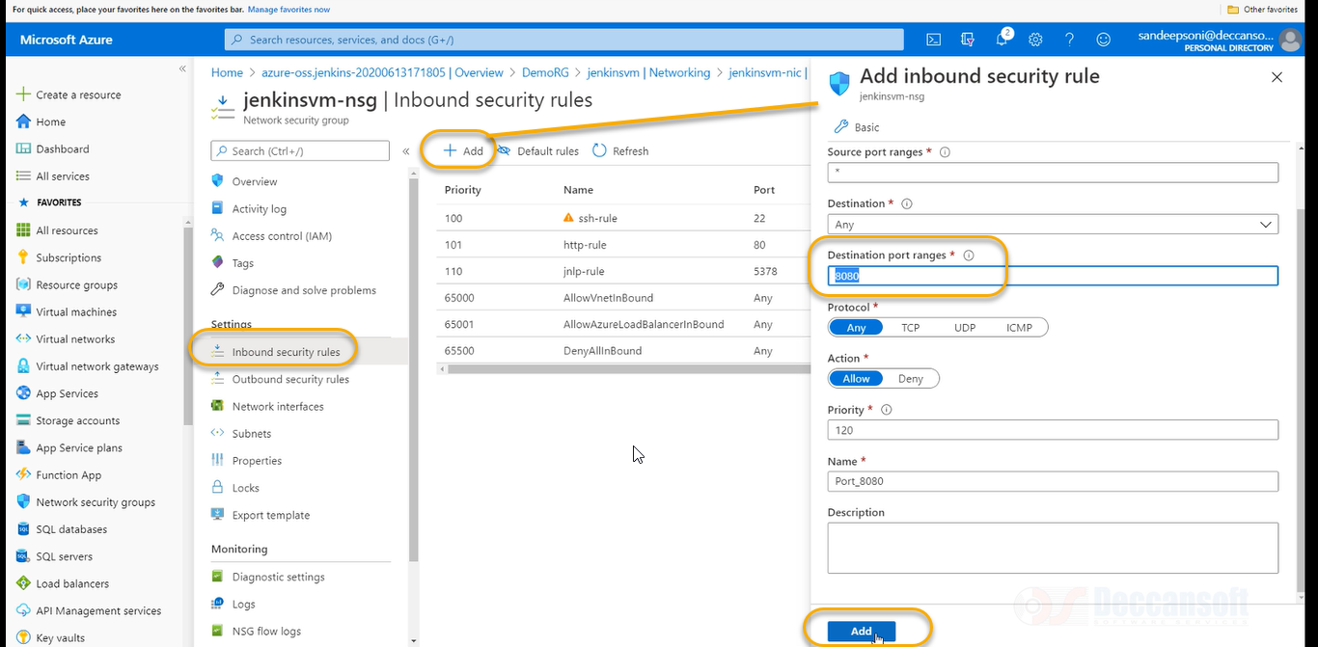

So Any AP-AT request to jenkins are now allowed basically if you use a service hook which we are going to create in Azure devops

Creating a new build job in Jenkins

In Azure Repo clone project from: https://azuredevopsdemogenerator.azurewebsites.net/?TemplateId=77371&Name=MyShuttle 16. Go to your Azure Repos and select the Clone option. Select Generate Credentials and enter a User name and Password. Click Save Git Credentials to save

My shuttle is java-based application we can clone the java project by browsing the azuredevopsdemogenerator.azurewebsite.net click on the choose template

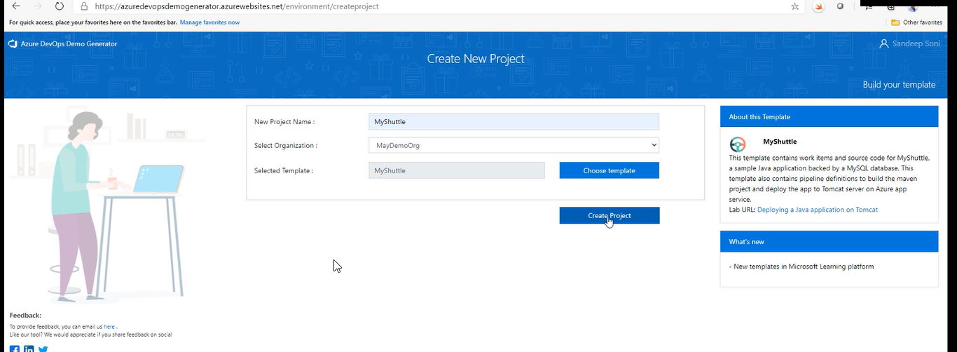

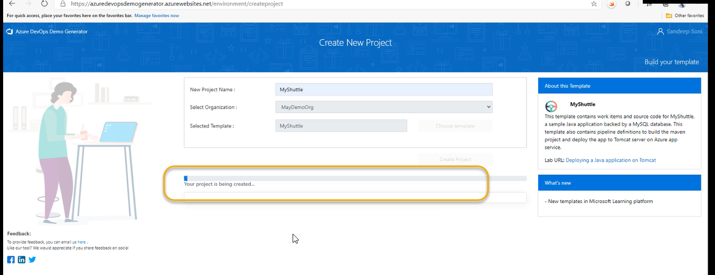

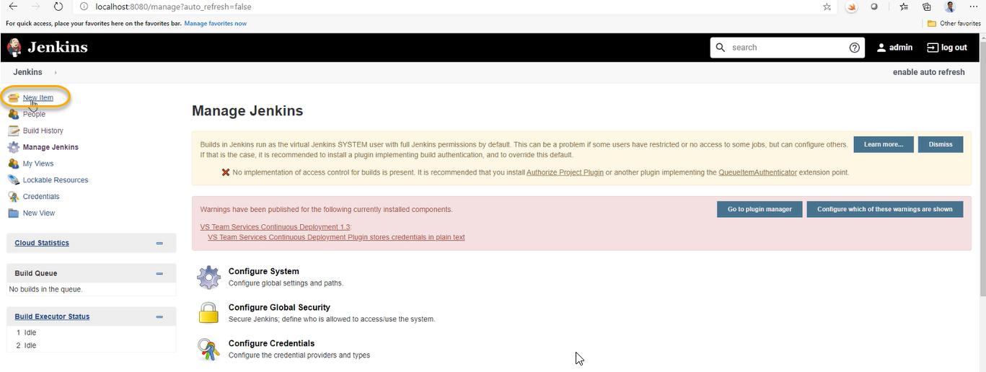

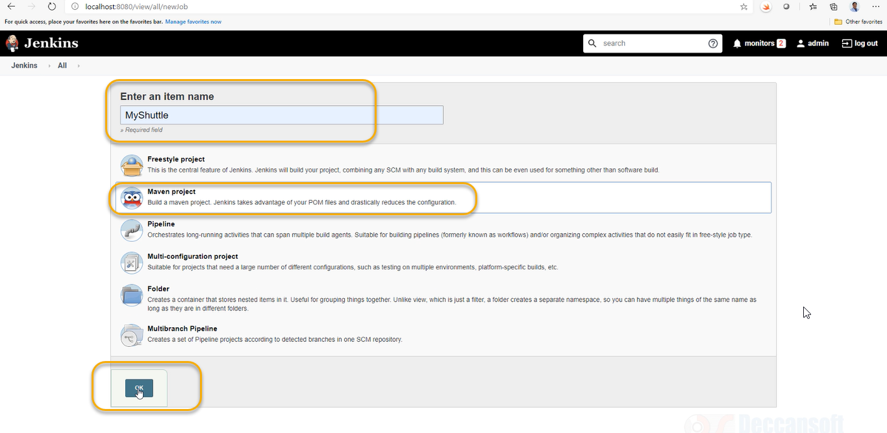

Dotnet > nuget and java > maven

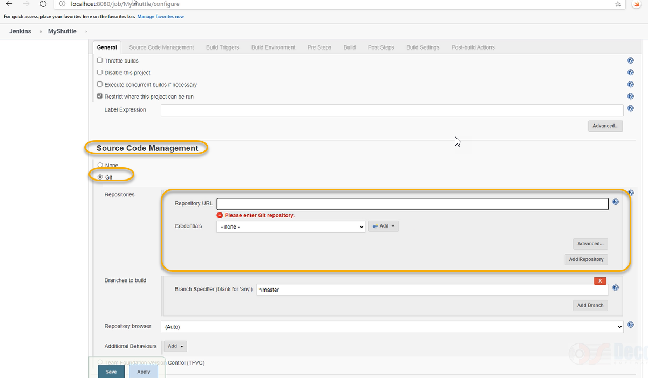

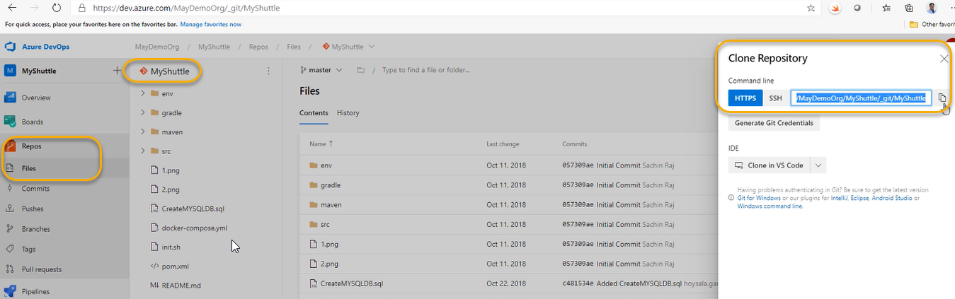

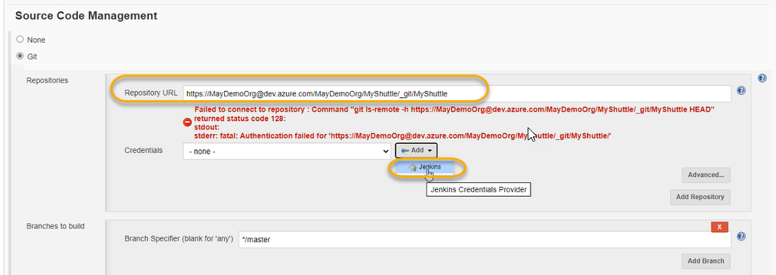

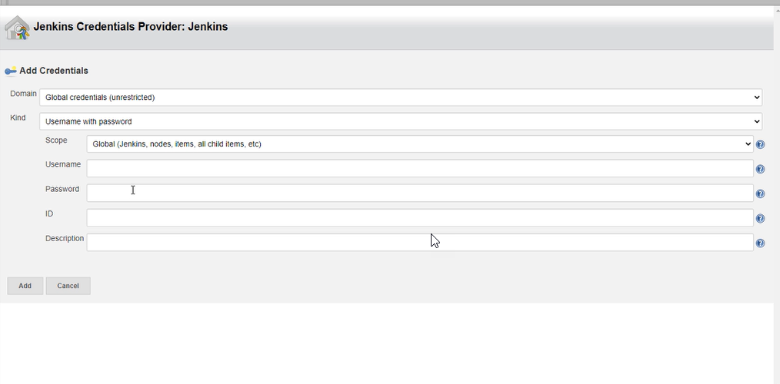

The username and password we can get from azure repo

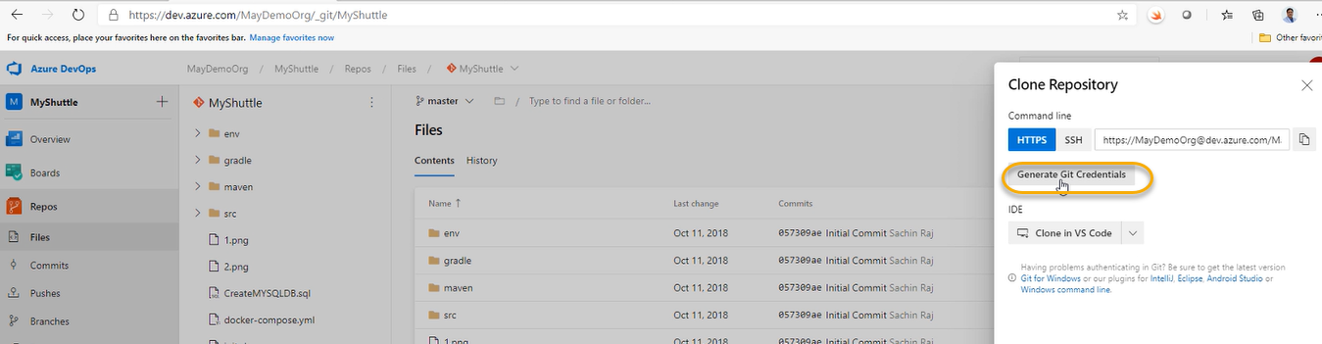

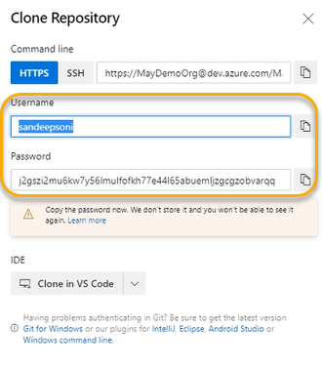

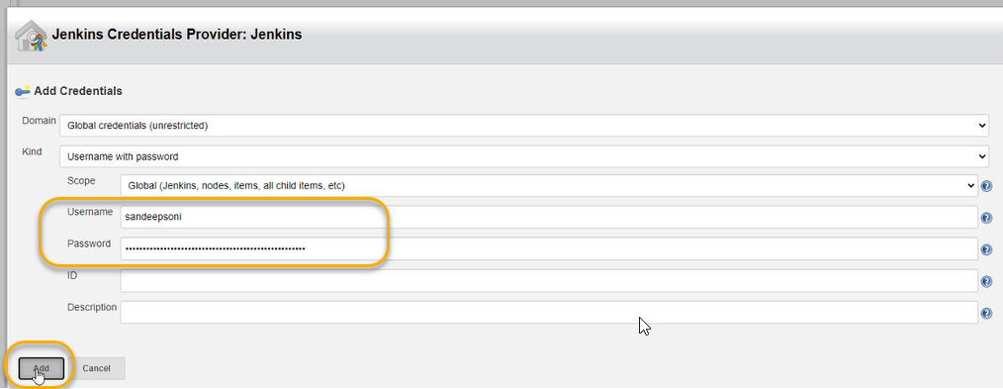

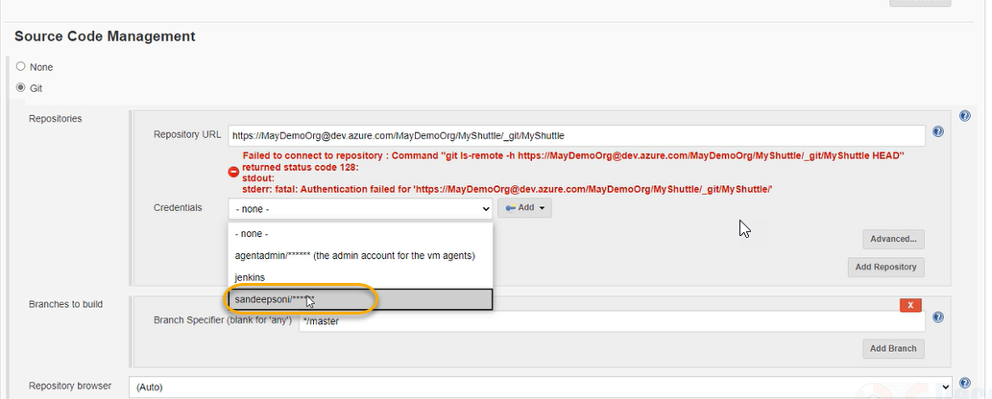

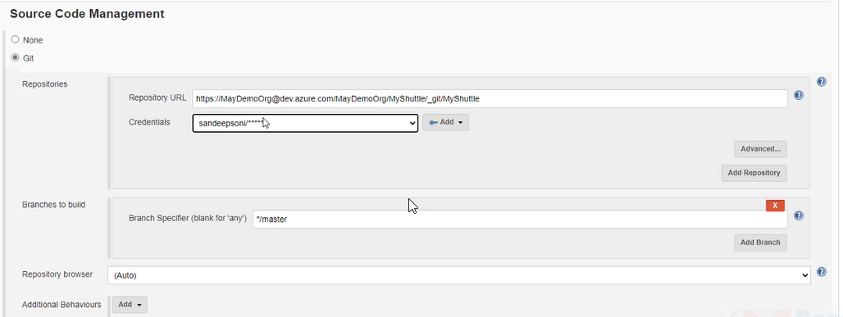

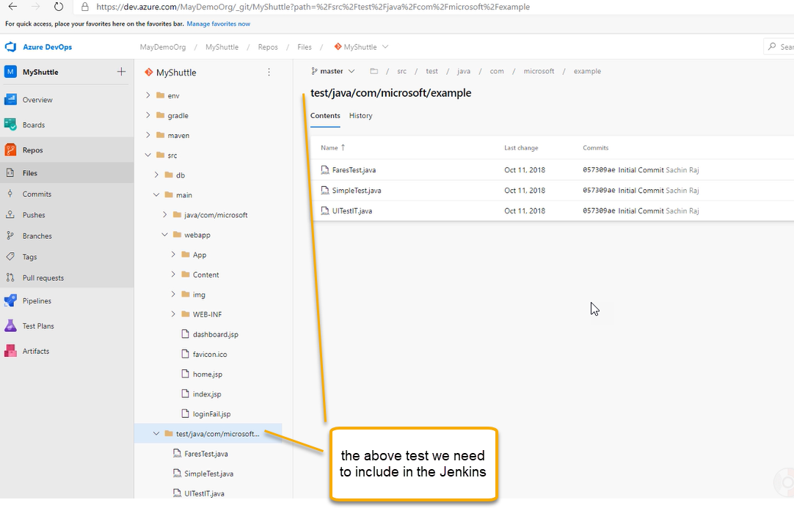

Pom.xml will give instructions in building java project

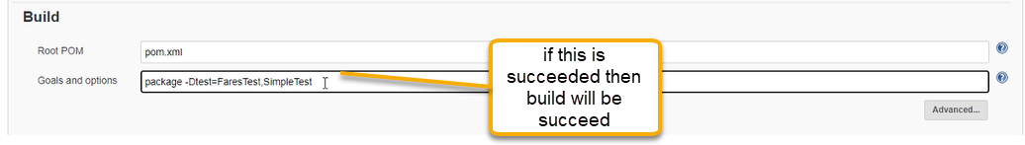

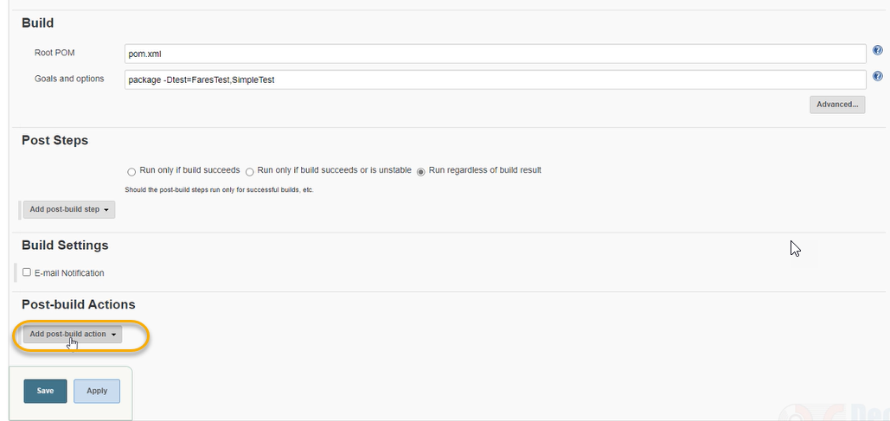

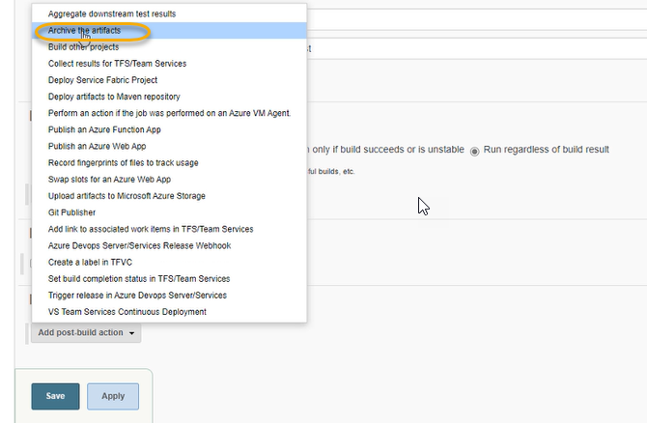

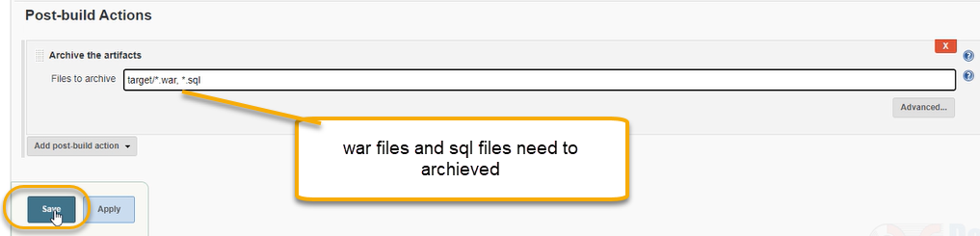

Completed the build configuration. Now perform the build and test

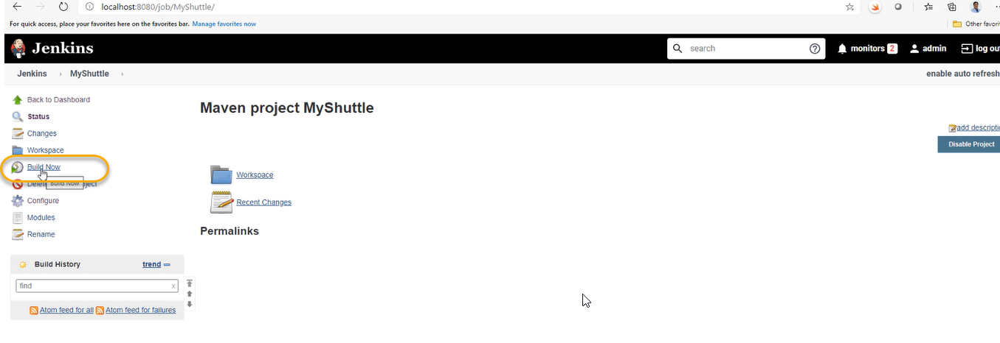

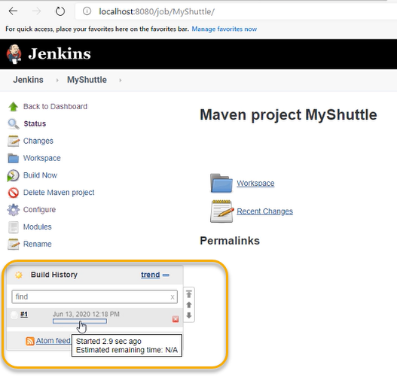

If this goes well and the build pipeline is successful

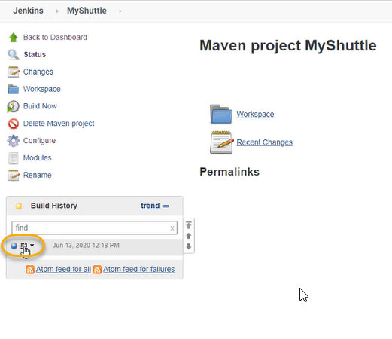

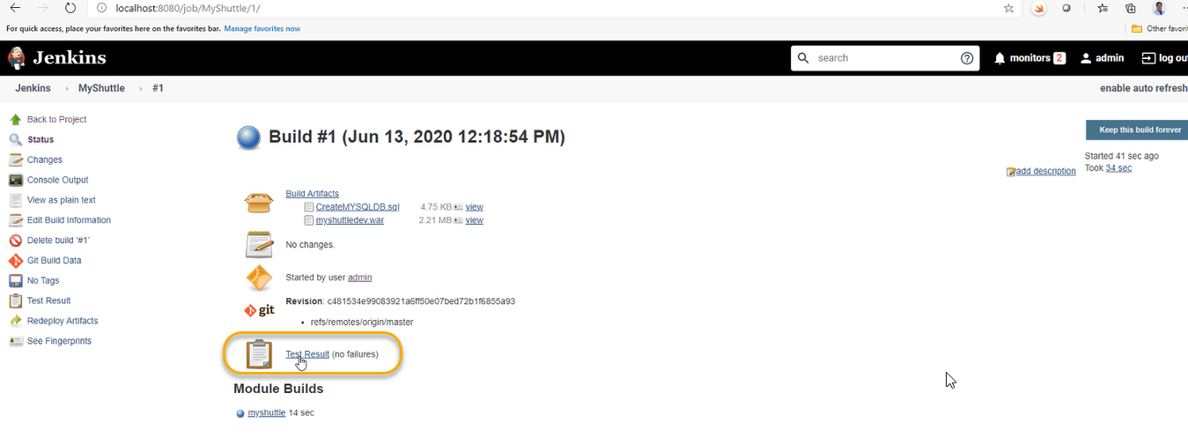

In the Build Artifacts the SQL and war has been created

Independently we are going to perform the build

I need to trigger the build when ever source code as made a change - CI

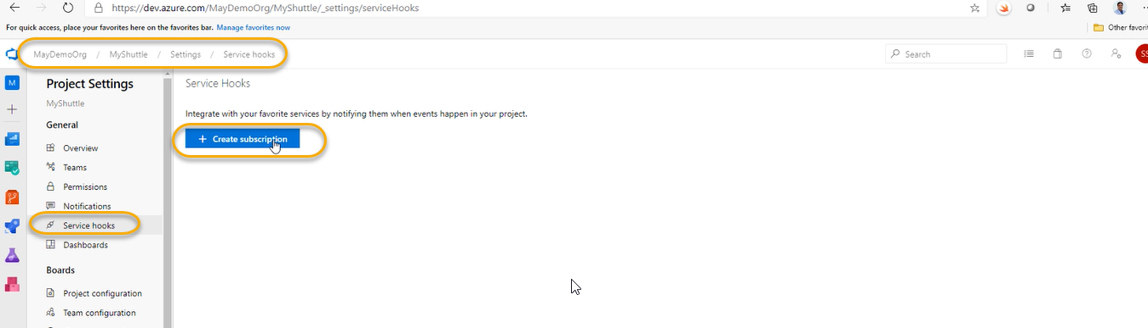

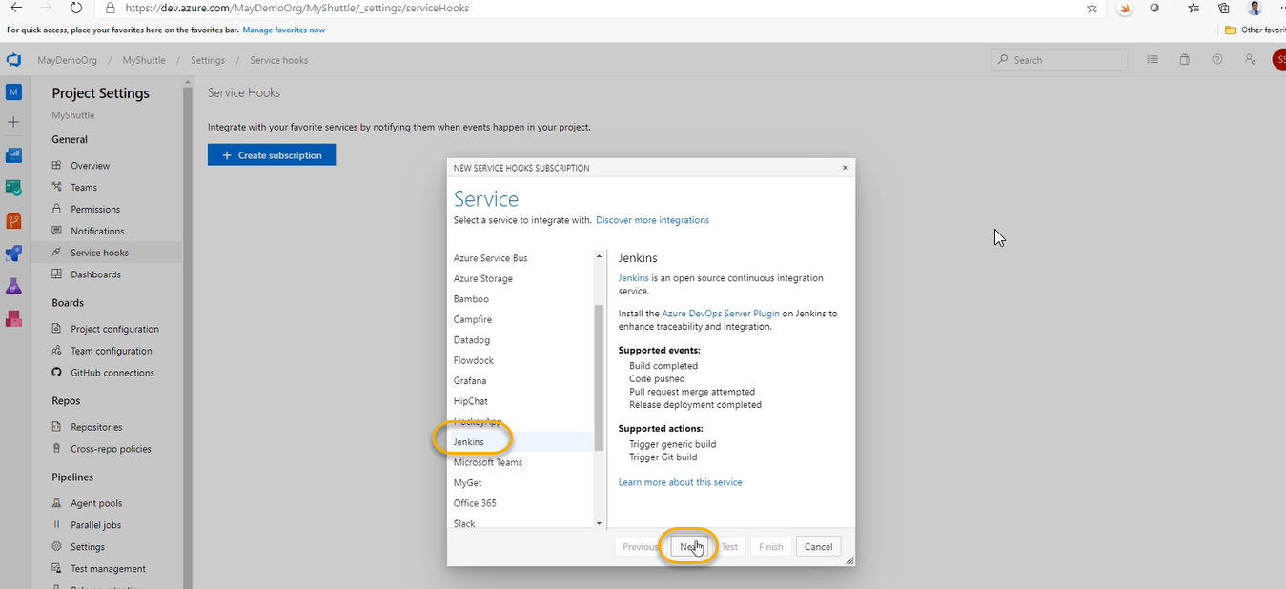

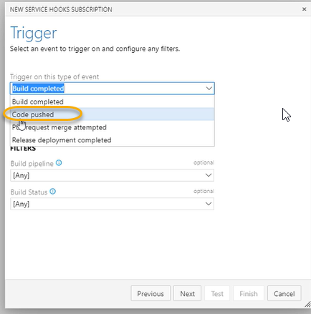

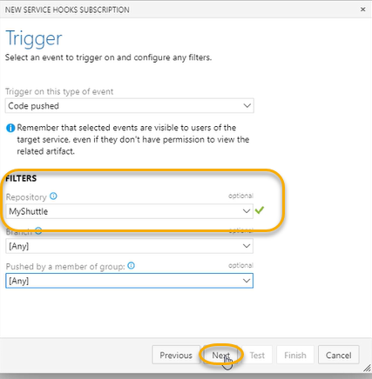

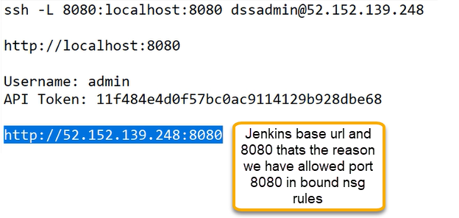

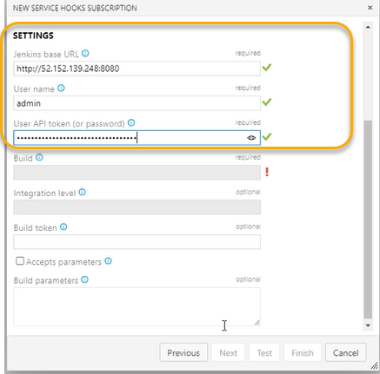

When we enter the above ones as highlighted automatically it will fetch the remaining fields which we see in the below screenshot

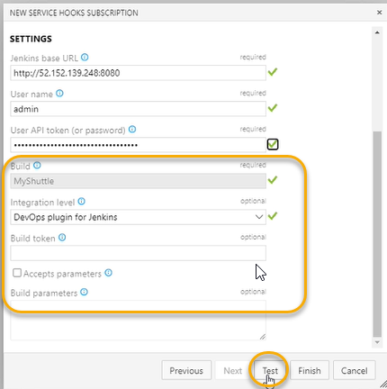

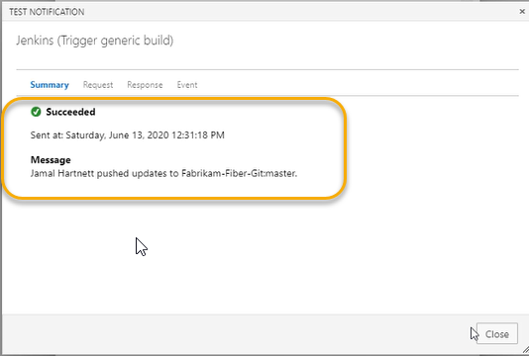

And click on Finish with respect to previous image

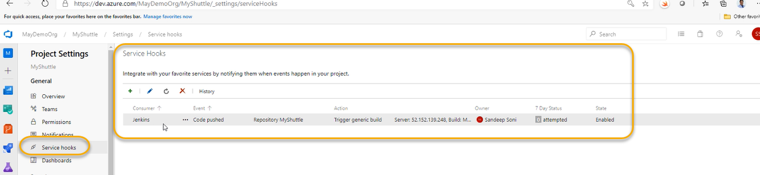

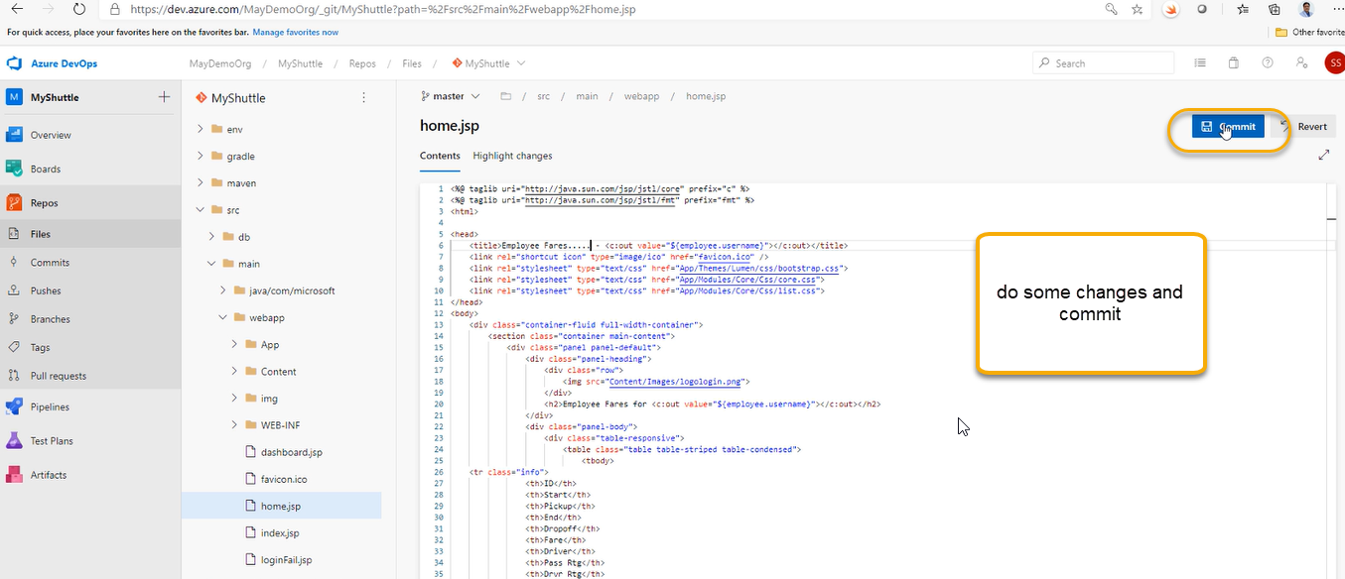

And a pop will come and click on commit the moment you commit here we can see in the service hook action can be there

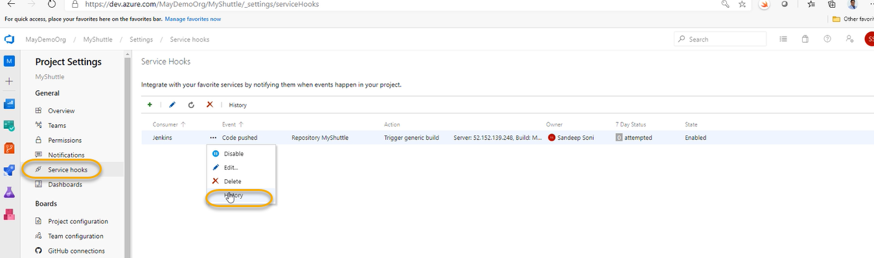

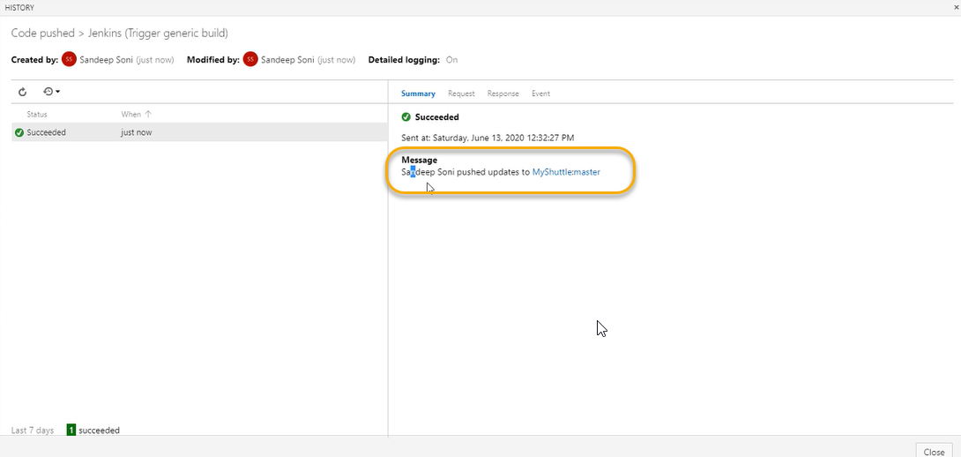

And also we can see in the Jenkins

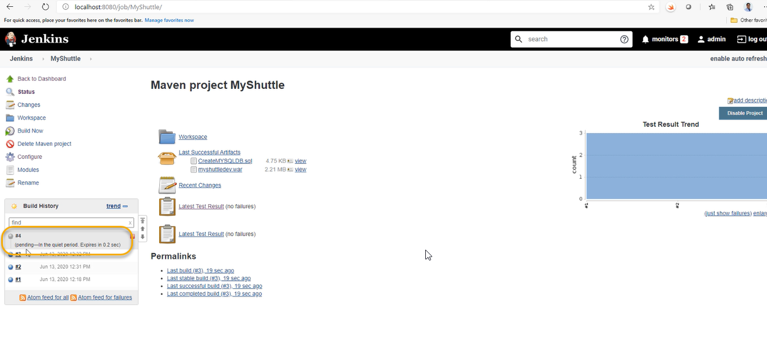

Every time if you make a change to source the new build will be automatically triggered

or from Azure DevOps we can connect service connection

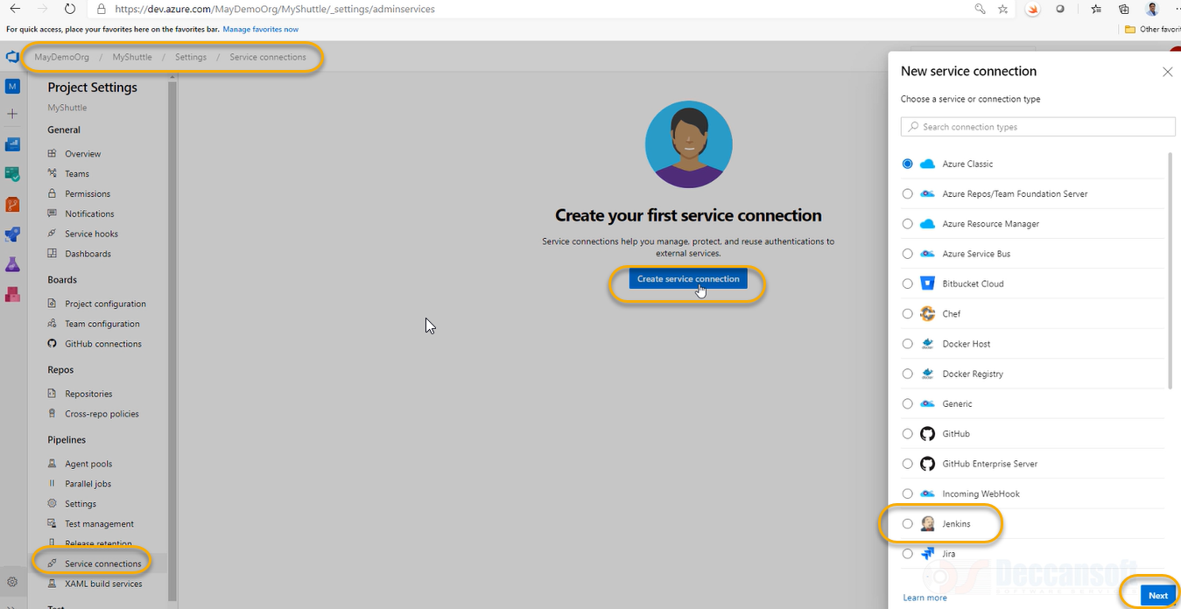

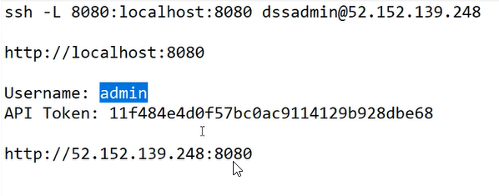

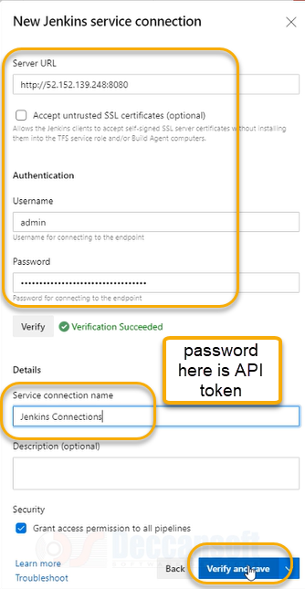

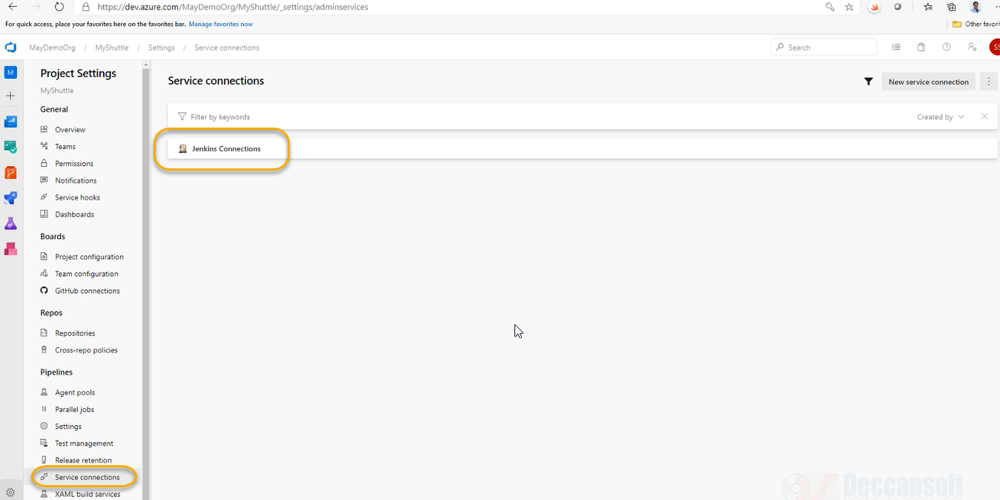

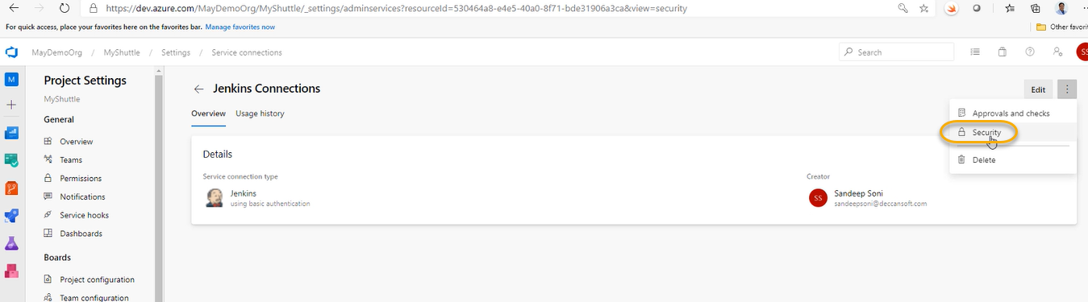

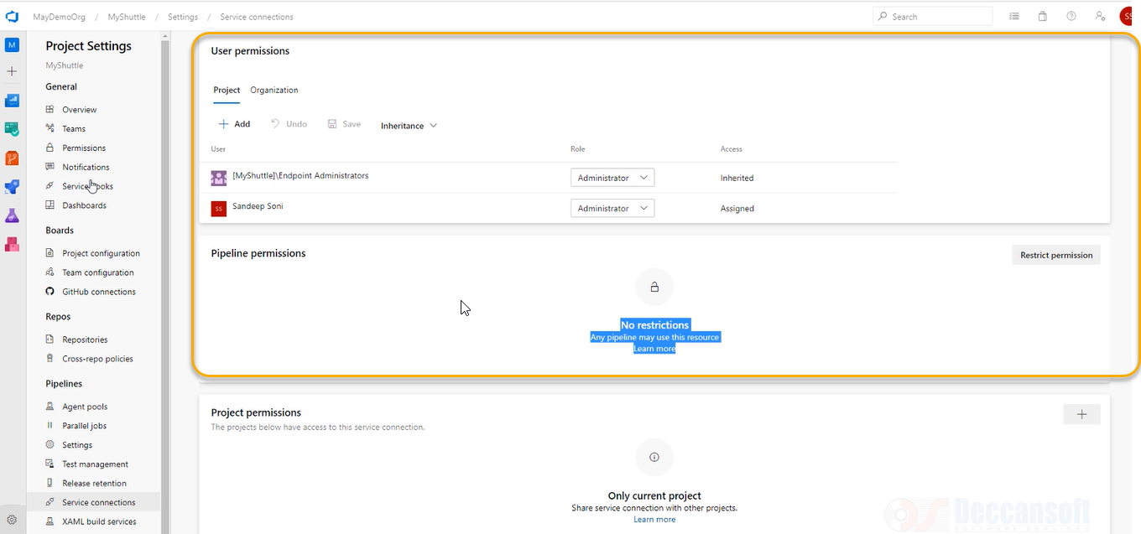

Create a new pipeline

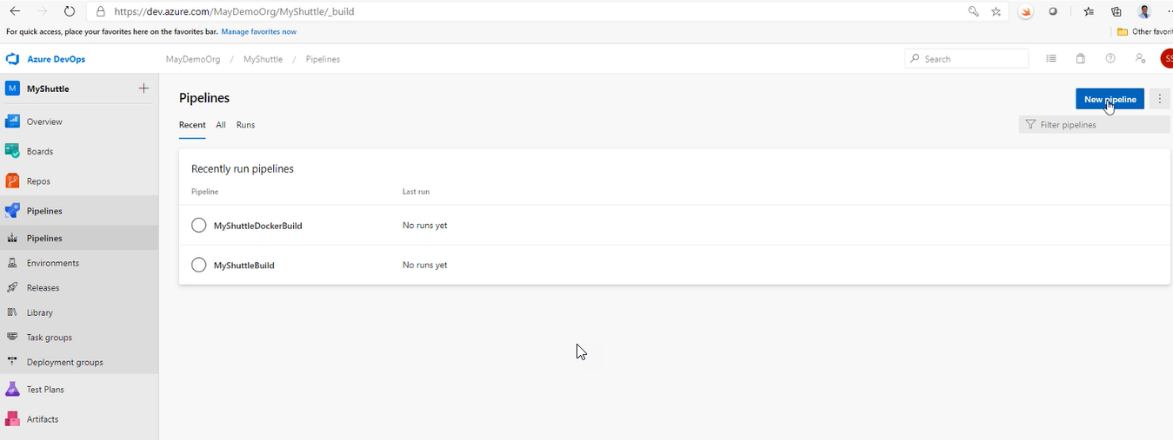

And select the classic editor

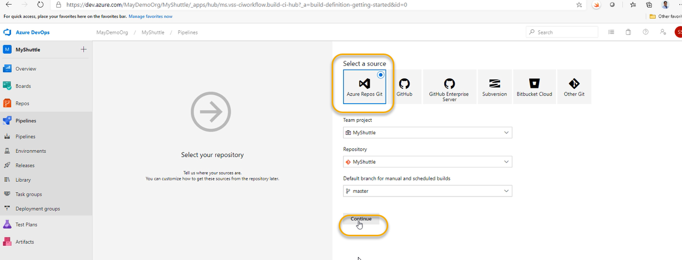

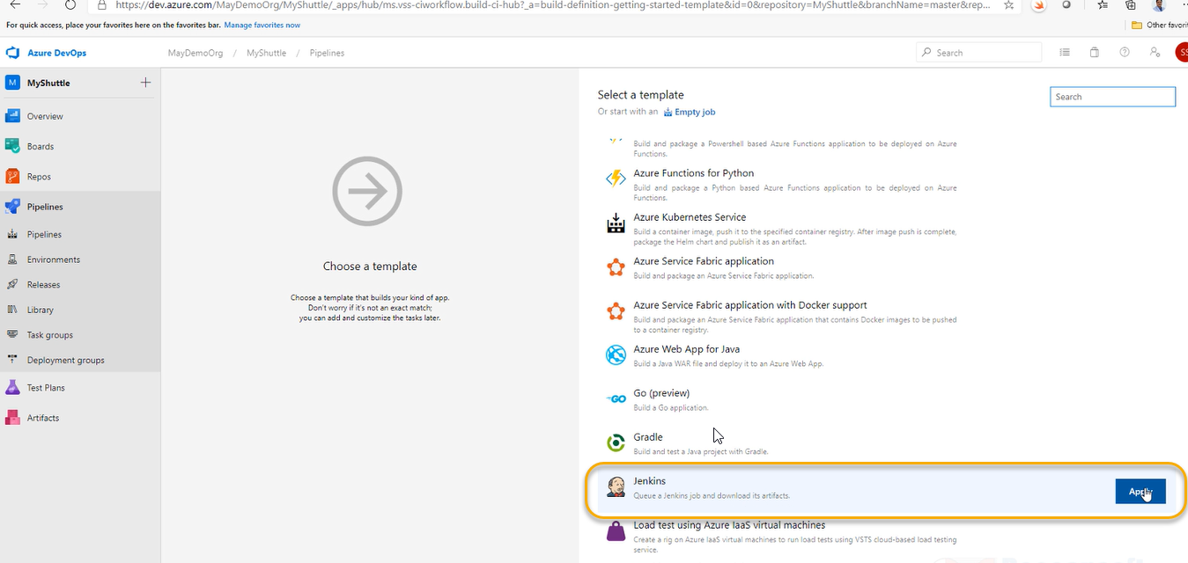

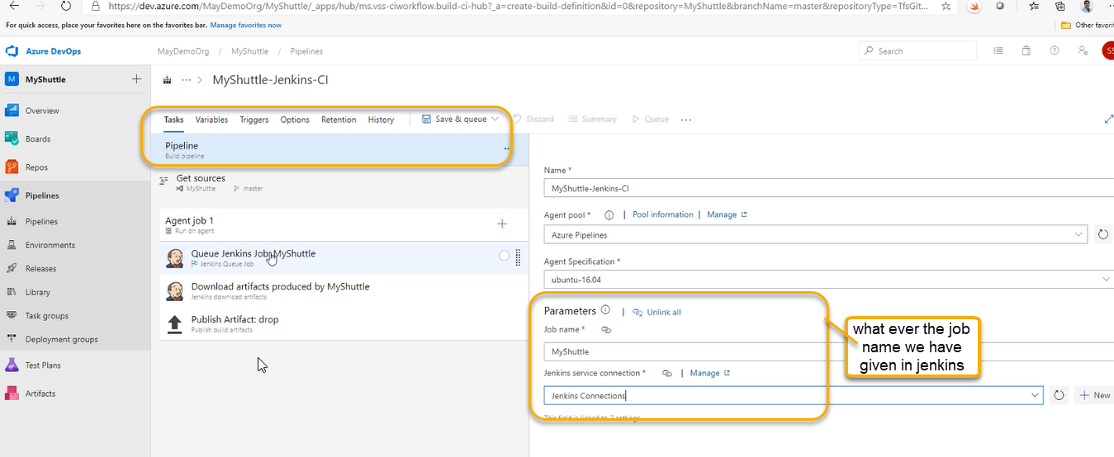

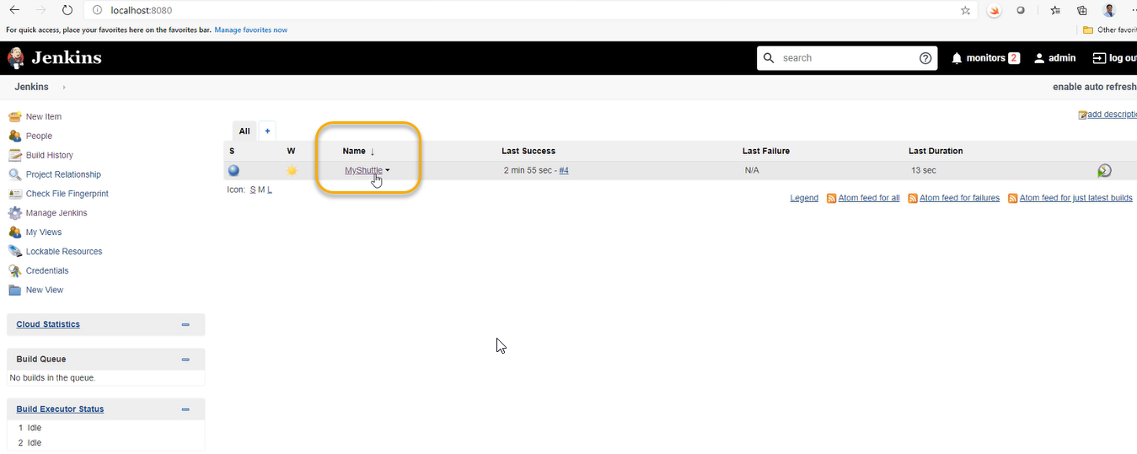

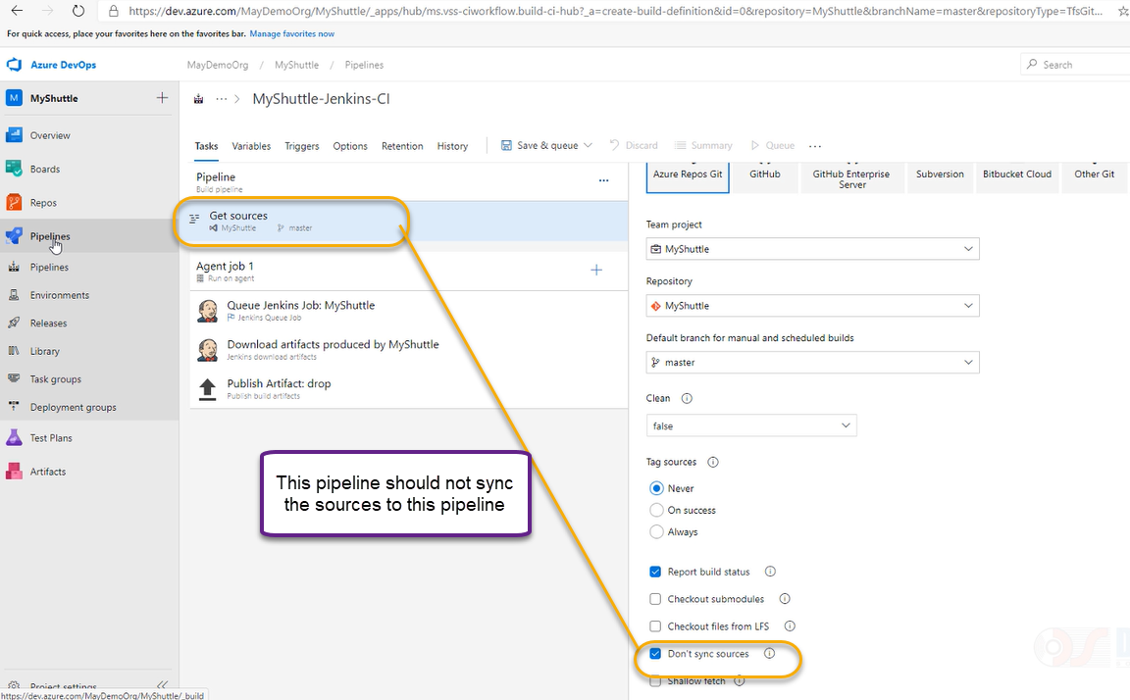

Click on save and queue

And again a pop up will come click on save and run

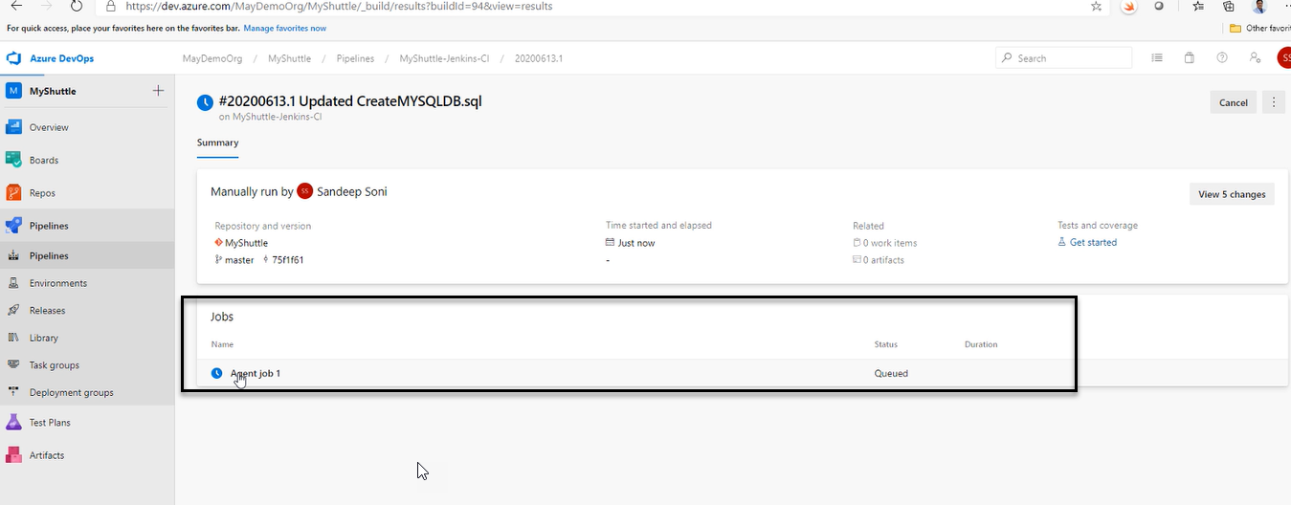

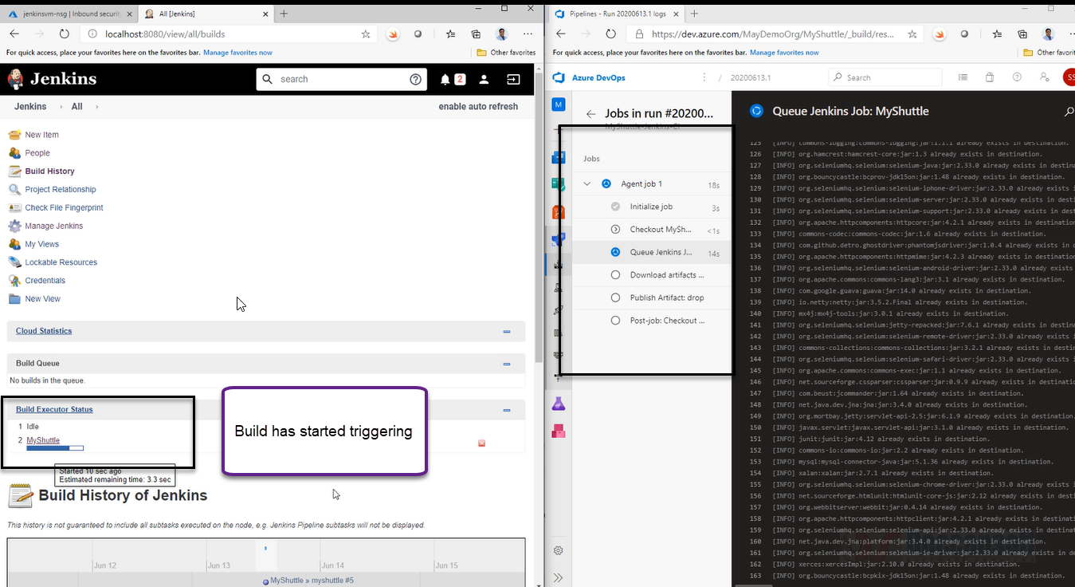

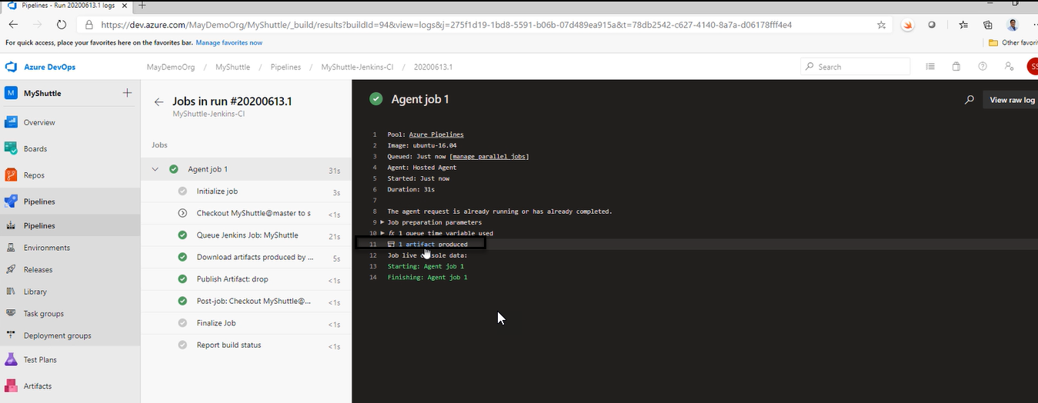

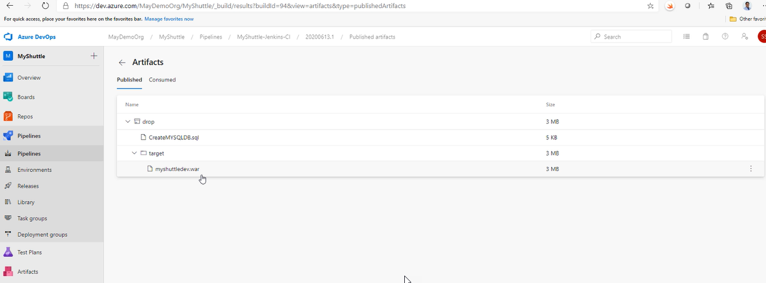

The artifacts produced and can be published a project

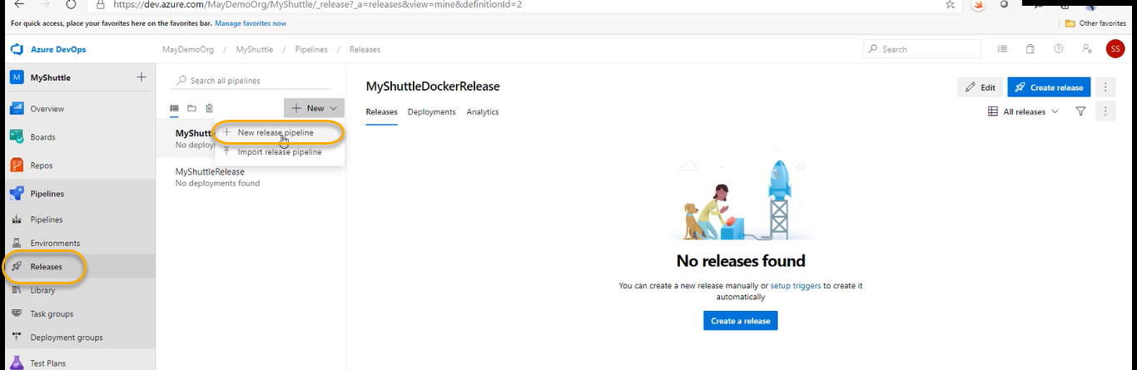

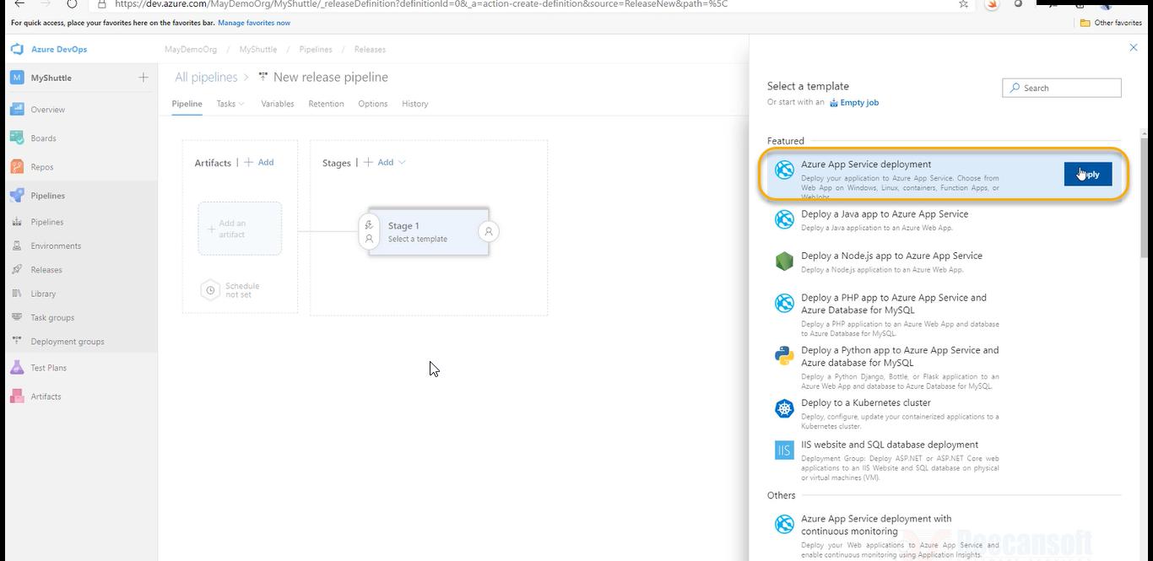

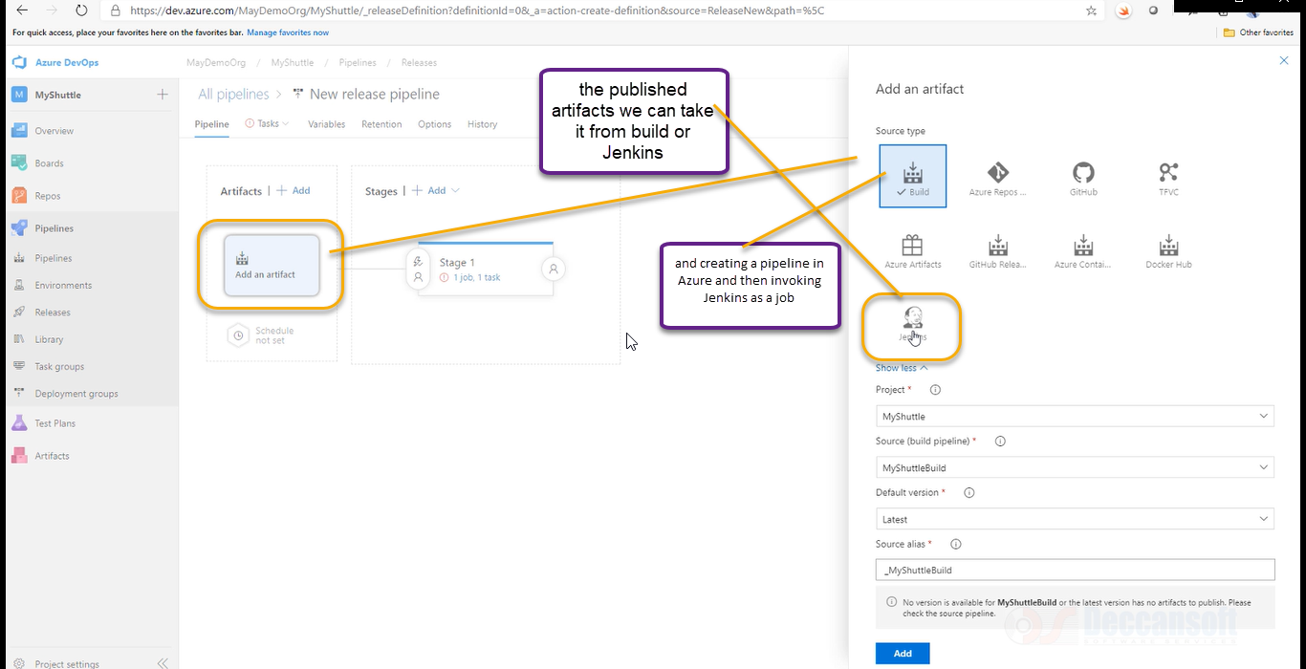

Once we have an artifact, we can publish to app service